Sunday, 8 August 2021

Eight days online workshop on Psychological Therapies concluded at HMV
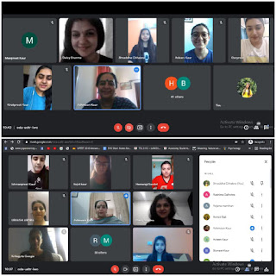

Freudian Psychological Society of Hans Raj Mahila Maha Vidalaya, Jalandhar organised an online eight days workshop for students of Psychology on various Psychological Therapies: Psychotherapy, Rational Emotive Behaviour Therapy, Cognitive Behaviour Therapy and Family Therapy under the able guidance of Prof. Dr. (Mrs.) Ajay Sareen.
Considering the need to learn about therapy as it helps build your thoughts, beliefs and attitudes affect your feelings and behaviour and teaches you coping skills for dealing with different problems, it was organized to enhance counseling skills of students. The fluent Resource Person was Dr. Daisy Sharma from Keshav Maha Vidyalaya, Delhi and was welcomed by Dr. Ashmeen Kaur, Head of Psychology Department and Society Incharge.
All the students of the Psychology Department joined the workshop. The speaker, Dr. Daisy Sharma enlightened the students with all the concepts and techniques of Psychoanalysis, Humanistic, Behavioral and cognitive approaches of psychology. It was a very indulging and communicative session for all as she engaged the students with activities, practical demonstration and quizzes.
Dr. Ashmeen Kaur and the students thanked Dr. Daisy Sharma for her presence and the information she provided to everyone. The workshop ended on a beneficial and informative note.

Thursday, 12 August 2021

International Webinar on “The Contribution of Arya Samaj and Hindi in the Freedom Struggle” at HMV

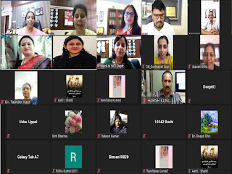
THe PG Department of Hindi and Department of Sanskrit hosted an International Webinar with the inspiring guidance of Principal Prof. Dr. (Mrs.) Ajay Sareen on “Contribution of Arya Samaj and Hindi in the Freedom Struggle” under the Amrit Mahotsav Series marking the celebration of 75th Independence Day. The Webinar began on a pious note with the lighting of lamp and recital of Gayatri Mantra. Principal Dr. Ajay Sareen offered a warm welcome to the worthy guests Dr. Sushma Malhotra, Adjunct Lecturer Queen’s College, City University, New York, Dr. Udyan Arya, Principal Guru Virjanand Gurukul Sanskrit College Kartarpur and Dr. Brahmved Sharma, Head Department of Hindi, DAV College Malout. Principal Dr. Ajay Sareen congratulated the organizers for the webinar and firmly supported the contribution of Arya Samaj and Hindi in the struggle for freedom. Arya Samaj provided the country with a strong platform and Hindi served to awaken the spirit of nationalism and patriotism through its literature. The world today can attain new heights of progress by utilizing the ideas propogated by Arya Samaj.

Tuesday, 21 September 2021

An Online workshop “Entrepreneurship in Herbal Products”

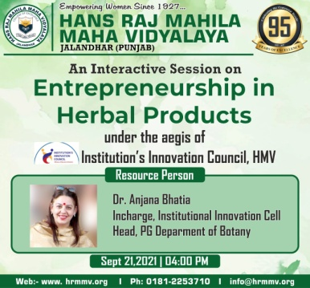
PG Department of Botany organized One Day National Workshop on “Entrepreneurship in Herbal Products” under DD Pant Botanical Society. Principal Prof. Dr. (Mrs.) Ajay Sareen stressed upon the need of getting the knowledge about herbal products, their production and empowering the women by setting up small set ups by utilizing the knowledge based on these herbal products. During COVID-19 people are looking on ayurveda for boosting immunity which is based on this traditional knowledge of plants & plant based products. She congratulated the department for organizing such a successful event.
The Resource Person Dr. Anjana Bhatia, innovation ambassador discussed about the role of basic plant sciences for being successful entrepreneur of herbal products. Demand for plants based cosmetics, medicines & other health care products have been increasing exponentially as they are non-toxic, have less side effects and easily available at affordable prices. India is one of the top 12 mega biodiversity centres of world which supplies major raw material of herbal products all over the world. So by having knowledge about plants you can be a successful entrepreneur as well as organic producer of such herbal products.
More than 700 students’ teachers, researchers from various institutes registered for the workshop. Dr. Nitika Kapoor gave vote of thanks. Dr. Shaveta, Mrs. Ramandeep, Ms. Harpreet Kaur & Dr. Shuchi from Botany Department were also present.

Wednesday, 29 September 2021

World Heart Day celebrated at HMV
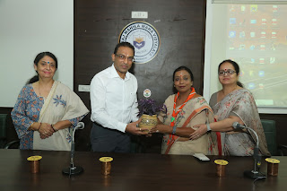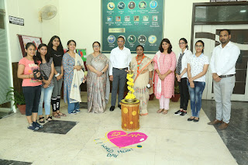

Department of Zoology of Hans Raj Mahila Maha Vidyalaya, Jalandhar organized an awareness seminar on “World Heart Day” under the assiduous guidance of Principal Prof. Dr. (Mrs.) Ajay Sareen and Co-ordination of Dr. Seema Marwaha, Head of Zoology Department. The seminar was facilitated by Dr. Nitish Garg, Senior Consultant and International Cardiologist and Director, CIMS. Principal Prof. Dr. (Mrs.) Ajay Sareen welcomed Dr. Nitish Garg by presenting a planter and a painting. She commented Dr. Nitish for his expertise as a heart surgeon along with being a noble soul. His motivational words heal the suffering souls and vouchsafe the fact that medicines cure the disease and doctors cure the patients.
Dr. Nitish highlighted the purpose behind the World Heart Day and advised to take great care of this precious organ. He elaborated on the causes and risk factors involved in the heart diseases. He listed the foods to be avoided as prevention is always better than cure. He also pointed out that the current sedentary life style and unhealthy diet are the major causes of heart disease. He also presented valuable tips on being healthy.

Friday, 29 October 2021

HMV Organized Awareness Campaign on Breast Cancer

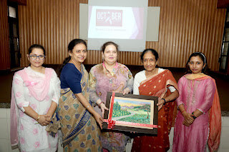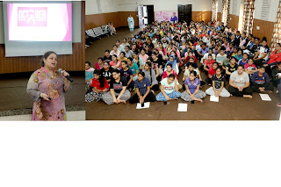

Youth Red Cross Society of Hans Raj Mahila Maha Vidyalaya,Jalandhar organized a seminar on Breast Cancer awareness to observe Breast Cancer awareness month under the able guidance of Principal Prof. Dr. (Mrs.) Ajay Sareen for the resident scholars. Mrs. Meenakshi Sayal, Coordinator resident scholars and Mrs. Deepshikha, Incharge Red Cross Society welcomed Dr. Shikha Chawla, Head of Department of Radiation Oncology, Patel Hospital, Jalandhar. Dr. Shikha Chawla delivered a talk to create awareness about early signs and symptoms of Breast Cancer. She also discussed about advancements in treatment of Breast Cancer. She advised that with proper diagnosis and treatment in the initial stages, Breast Cancer can be one of the most treatable forms of Cancer. She also encouraged women to get regular mammogram after the age of 40. She also advised to take healthy diet and maintain healthy body weight. She responded to the queries raised by the students to their satisfaction. On this Occasion Dr. Simmi Garg, Dr. Vandna Thakur, Ms. Nishita and Ms. Manpreet were also present.

Friday, 1 October 2021

HMV organized exhibition on Best Out of Waste

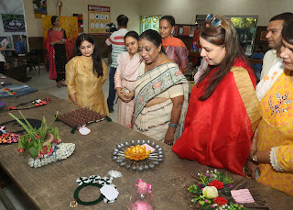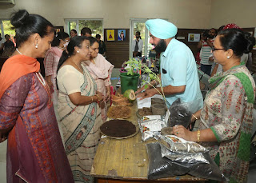

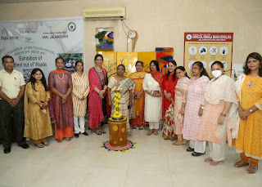
Hans Raj Mahila Maha Vidyalaya, Jalandhar organized one day exhibition on “Best out of waste” in collaboration with Municipal Corporation, Jalandhar under Azadi Ka Amrit Mahotsav. People from different areas of Jalandhar participated in the exhibition. Number of artistic articles were displayed in the exhibition using waste material. There were two categories i.e. Entrepreneur and Common Society. The Chief Guest of the exhibition was Dr. Sumita Abrol, Assistant Health Officer, Municipal Corporation, Jalandhar. Ms. Ramanpreet Kaur, Programme Coordinator Swachh Bharat Mission (Urban), Mrs. Rekha Kashyap, T.V. artist & Mrs. Monika Sekri, Senitary Inspector, Municipal Corporation, Jalandhar were also present. Principal Prof. Dr. (Mrs.) Ajay Sareen said that we all should be aware about recycling. HMV has been tagged as Green Champion and organize Best Out of Waste programme from time to time. She said that the motive of this exhibition is not only to inhance the creativity of artists but to promote entrepreneurship as well. She gave her blessings to all the participants. Dean Innovation Dr. Anjana Bhatia said that such programmes are helpful in promoting the creativity and entrepreneurship in artist. HMV always take a stepahead in such programmes. Around 100 schools participated in this exhibition. The students made different things with Paper Brush, Bottles, Old mats, Newspapers, CDs etc. The children of Special School also participated in this exhibition and competition. In Entrepreneur Category Mr. Harpreet Singh got 1st prize and Ms. Ramanpreet Kaur got 2nd prize. In 2nd category Team Ridhi got 1st prize, Sudipa got 3rd prize, Plasha got 4th prize, Sahil got 5th prize, Khushi got 6th prize and shruti got 7th prize. Consolation prize was won by Ritika Joshi, Ashi, Divya & Diya. The Incharges of the programme were Dr. Rakhi Mehta, Mrs. Navneeta, Co-Incharge Dr. Shailender Kumar.

Tuesday, 30 November 2021

HMV organized an International Webinar on Punjabi Language

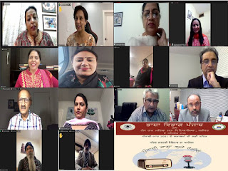

Hans Raj Mahila Maha Vidyalya, Jalandhar in collaboration with Bhasha Vibhag Punjab organized an International Webinar under the Punjabi Month 2021 celebrations on Punjabi Language and Radio. Principal Prof. Dr. (Mrs.) Ajay Sareen and Dr. Veerpal Kaur, Deputy Director Bhasha Vibhag accorded a warm welcome to Ms. Ramanpreet Kaur, Shamsheer Production, Ms. Shameel Jasvir, Radio Red FM 889, Toranto, Canada, Ms. Gurdishpal Kaur Bajwa, Chief Editor, Media Punjab, Germany, Ms. Harjinder Kang, Radio KBIF 900 AM, California, Ms. Harjit Kaur, Radio Spice, Auckland and Ms. Navjot Dhillon, Radio Sher-e-Punjab AM 600, Vancouver, Canada. Principal Dr. Ajay Sareen elaborated on the role of Media and Radio in our lives by saying that Radio belongs to all ages and our day breaks amongst the soulful melodies and news upon the Radio. It is a medium to pour our heart out in our own language. HMV students are spread all along the world and with their aid, the institution is always determined to bring up social issues through Radio. Dr. Veerpal Kaur appreciated the efforts of the institution for promoting Punjabi language. Bhasha Vibhag is also devoted in the service of Punjabi Language and celebrates November as Punjabi month every year. She applauded the support of all Punjabis in foreign lands who are putting efforts towards Punjabi language. Ms. Navjot Kaur detailed on the history of Radio in Vancouver. Ms. Gurdishpal Kaur, an alumnae of HMV felicitated the institution for attaining such heights and talked about status of Punjabi language in Germany. Mr. Shameel Jasvir highlighted the present condition of Punjabi throughout the world. Ms. Ramanpreet presented a vote of thanks to the experts. She also spoke about the intense connection between Radio and language. The event was organized by Ms. Rama Sharma, Head of MCVP Department and moderated by Ms. Kuljit Kaur from Punjabi Department.

Dr. Sushma Malhotra held an elaborative discussion on the role of Arya Samaj and Hindi poets and scholars in the freedom struggle. She also presented the ideology of Swami Dayanand Ji. Dr. Udyan Arya propagated the view that change is initiated through ideas. If we wish to bring a change in the society, we need to direct the youth towards thoughts and meditation. Dr. Brahmved Sharma detailed on historical perspective of Arya Samaj and Hindi Literature. He felt elated to be a part of such thought provoking Webinars. Towards the end, Dr. Meenu Talwar HOD Sanskrit presented a vote of thanks. The webinar was moderated by Dr. Jyoti Gogia, Head of Hindi Department. Mrs. Pawan Kumari and Dr. Deepti Dhir also attended the webinar along with the students.

Tuesday, 30 November 2021

HMV organized an International Webinar on Punjabi Language

Hans Raj Mahila Maha Vidyalya, Jalandhar in collaboration with Bhasha Vibhag Punjab organized an International Webinar under the Punjabi Month 2021 celebrations on Punjabi Language and Radio. Principal Prof. Dr. (Mrs.) Ajay Sareen and Dr. Veerpal Kaur, Deputy Director Bhasha Vibhag accorded a warm welcome to Ms. Ramanpreet Kaur, Shamsheer Production, Ms. Shameel Jasvir, Radio Red FM 889, Toranto, Canada, Ms. Gurdishpal Kaur Bajwa, Chief Editor, Media Punjab, Germany, Ms. Harjinder Kang, Radio KBIF 900 AM, California, Ms. Harjit Kaur, Radio Spice, Auckland and Ms. Navjot Dhillon, Radio Sher-e-Punjab AM 600, Vancouver, Canada. Principal Dr. Ajay Sareen elaborated on the role of Media and Radio in our lives by saying that Radio belongs to all ages and our day breaks amongst the soulful melodies and news upon the Radio. It is a medium to pour our heart out in our own language. HMV students are spread all along the world and with their aid, the institution is always determined to bring up social issues through Radio. Dr. Veerpal Kaur appreciated the efforts of the institution for promoting Punjabi language. Bhasha Vibhag is also devoted in the service of Punjabi Language and celebrates November as Punjabi month every year. She applauded the support of all Punjabis in foreign lands who are putting efforts towards Punjabi language. Ms. Navjot Kaur detailed on the history of Radio in Vancouver. Ms. Gurdishpal Kaur, an alumnae of HMV felicitated the institution for attaining such heights and talked about status of Punjabi language in Germany. Mr. Shameel Jasvir highlighted the present condition of Punjabi throughout the world. Ms. Ramanpreet presented a vote of thanks to the experts. She also spoke about the intense connection between Radio and language. The event was organized by Ms. Rama Sharma, Head of MCVP Department and moderated by Ms. Kuljit Kaur from Punjabi Department.
To conclude the seminar, Dr. Seema Marwaha presented the vote of thanks to Dr. Nitish for sparing time from his busy schedule and creating awareness of the heart diseases. A Poster Making and Slogan Writing Competition was also organized on the occasion. The seminar was moderated by Dr. Anjana Bhatia. The members of the faculty, staff and students attended the seminar and got awareness of the disease.

Friday, 14 January 2022

Workshop on Banking Software ‘Finacle’ organized at HMV

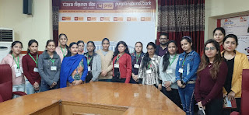
A workshop on Banking Software ‘Finacle’ was organized by the PG Department of Commerce and Management of Hans Raj Mahila Maha Vidyalaya, Jalandhar under the able guidance of Principal Prof. Dr. (Mrs.) Ajay Sareen for the students of B.Voc (Banking and Financial Services). On this occasion, the students visited the circle office of Punjab National Bank Jalandhar. Mr. Amit Kumar, Chief Manager, IT welcomed the students and gave a brief introduction of digital banking and its importance in today’s times. Ms. Sakshi Puri, Officer, IT explained the use of latest version of Finacle. She explained core banking solution, modules and user access system in Finacle. She gave information to students regarding account opening, CIF (Customer Informtion File). She also explained the relevance of accurate CIF, CRM, Employees Record Keeping, Account Enquiry System, Checking of Statements, Finhelp, Report Generation, SOL ID etc. She also discussed various shortcut commands used in Finacle. The workshop ended with a doubt clearing session. Principal Prof. Dr. (Mrs.) Ajay Sareen congratulated Head of the Department, Mrs. Meenu Kohli and appreciated the efforts of the Department. On this occasion Ms. Harmeen Kaur, Manager IT, PNB Circle Office, Ms. Riya Makkar, Manager IT, PNB Circle Office and Dr. Minakshi Duggal Mehta from HMV were also present.

Thursday, 3 February 2022

HMV Organized Guest Lecture on ‘Online Trading Operations’

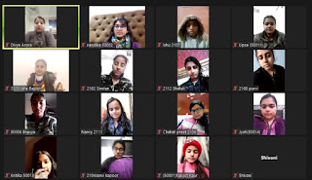
A series of Guest Lectures on ‘Online Trading Operations’ were organized by the PG Department of Commerce and Management of Hans Raj Mahila Maha Vidyalaya, Jalandhar for the students of B.Voc (Banking and Financial Services) under the able guidance of Principal Prof. Dr. (Mrs.) Ajay Sareen . Mrs. Divya Nanda, Cluster Manager, RBL Bank, Model Town Branch, Jalandhar was the Resource Person. The students were given practical insights into the online trading operations such as Depository, NSDL, CDSL, Demat, Clearing and Settlement Procedure, SENSEX, NIFTY, Stop Loss, Order Booking, Statement of Shares etc. The actual placement of Trading Order was also demonstrated to the students. Principal Prof. Dr. (Mrs.) Ajay Sareen congratulated Head of the Department Mrs. Meenu Kohli and motivated to organize such events in future also.

Monday, 7 February 2022

The Freudian Psychological Society of HMV Organized Workshop

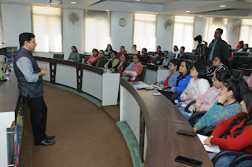
The Freudian Psychological Society of Hans Raj Mahila Mahavidyalaya, Jalandhar organized workshop on “Anxiety and Mood Disorders : Let’s Understand Them Better” under the able guidance of Principal Prof. Dr. (Mrs.) Ajay Sareen. The Resource Person, Mr. Atul Madan, Clinical Psychologist, NHS Hospital, Jalandhar was welcomed by Dr. Ashmeen Kaur, Head of Psychology Department with a planter and a painting by the students of HMV as a token of appreciation. In the course of the workshop Mr. Atul Madan discussed the clinical and pathological aspects of Anxiety Disorders and covered the various spectrums of mood disorders and their underlying symptoms. Mr. Madan also talked about the key features of an effective counselling session and discussed case studies. The interactive session was attended by more than 100 students from various streams, who actively participated and asked questions throughout the session. Mr. Madan addressed the queries very enthusiastically, encouraged the students to have and open conversation on mental health and guided them by presenting inputs on how to become an impactful counsellor. Ms. Harmanjeet Kaur, Ms. Pragya Sharma, Ms. Niharika Mazumdar and Ms. Shruti Bidani were also present on this occasion.

Monday, 28 March 2022

HMV Competitive Examination Hub organized Workshop on Aptitude of Reasoning
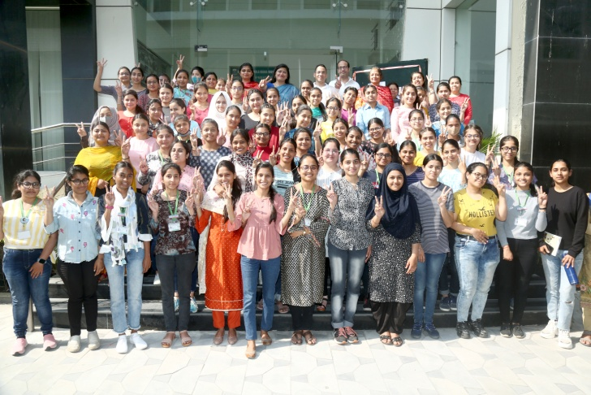

Hans Raj Mahila Maha Vidyalaya, Jalandhar is constantly on the move to empower the students on Professional fronts and to prepare them well for Competitive Exams. Workshop on ‘Aptitude of Reasoning’ was organised under the able guidance of Principal Prof. Dr. (Mrs.) Ajay Sareen. Green welcome was accorded to the Resource Person Mr. Vipin Khandwal, Director TIME Institute by Mrs. Navroop and the organising Committee. Mrs. Binoo Gupta, Incharge of HMV Competitive Examination Hub told that this workshop enabled students to learn tricks of mental ability, verbal ability and quantitative aptitude and announced that in last week of March Coaching Classes for Banking Exam and other Competitive Exams (UGC) are also going to start in which even boys can also take admission. The registration is open on first come first serve basis. The classes would be conducted in the evening and it would be a two months course. It was an interactive session followed by question answer round. Principal Dr. Ajay Sareen said such workshops and coaching classes are need of the hour and it creates confidence in the minds of the aspirants. Dr. Shallu Batra, Incharge UGC coaching emphasized on PG students to give UGC exam with full preparation as it can pave way for research fellowship too. On this occasion Mrs. Gagandeep, Incharge Banking Coaching presented Vote of thanks. This workshop was attended by students of final year graduate classes and all students of post graduation classes. On this occasion Mrs. Loveleen, Ms Harmanu Paul and Mr. Vidhu Vohra Were also present

Thursday, 31 March 2022

Skilled Course Certification Programme in Investor Education and Awareness at HMV
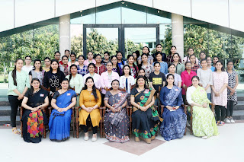

A 5 Days SKILLED COURSE CERTIFICATION PROGRAMME IN INVESTOR EDUCATION AND AWARENESS was organized by Commerce club of PG Department of Commerce and Management of Hans Raj Mahila Maha Vidyalaya. It was organized in collaboration with NiSM- An Educational Initiative by SEBI and Kotak Securities Ltd., under the able guidance of Principal Prof. Dr. (Mrs.) Ajay Sareen. As per the tradition of HMV, Program started with Gaytri Mantra to seek blessings of God Almighty. The session began with formal welcome and green greetings by Coordinator Mrs. Binoo Gupta, Dean Student Welfare, Mrs. Meenu Kohli, Head of PG Department of Commerce and Management, Incharge- Mrs. Kajal Puri and Dr. Jaspreet Kaur (Asstt. Prof in Commerce). Mrs. Binoo Gupta told the purpose of this skilled course is to make girls students financially literate and empowered by imparting them knowledge of making investments for future security. The Resource Person of the Day 1was Dr. Ashish Arora, Head UBS, GNDU College, Jalandhar who enlightened the students with his expertise on aspects of Financial Markets, Stakeholders and decision making criteria for various avenues of investment by deliberating on “Entrepreneurial Opportunity in Financial Markets". It was an interactive session helping students thinking out of box strategy. The real life practical examples quoted by him inculcated the spirit of investing and students were fully equipped with knowledge of taking calculative risks during the session. On Day 2 and day 3 Resource Person was Surya Kant Sharma, Senior Consultant AMFI(Association of Mutual Funds in India) and former DGM SEBI with his expertise on aspects of “Financial Empowerment through Wealth Creation” and rule of compounding. He highlighted the special schemes on “Mutual Fund Investment can fulfill your Financial Dreams”. He emphasized on use of money effectively to create money by proper financial planning. On Day 4 & 5 Resource Person was Ms. Anita Saini from NiSM discussed the importance of Investments, IPO’S Listing Procedures and imparted talk on “Financial Education” to students. She also guided students about career opportunities. E-certificates from NiSM were also given on the basis of online quiz conducted in the session. All the sessions were highly interactive, knowledgeable and have given insight to be prosperous in life one has to save and invest early as soon as possible. Principal Prof. Dr. (Mrs.) Ajay Sareen emphasized that the skill courses is the need of the hour and encouraged students to implement the idea so to gain real advantage of investments. She congratulated the Commerce club faculty members for taking this initiative. The stage was conducted by Mrs. Anchal and Ms. Anmol and technical assistance by Mr. Vidhu and Mr. Veerinder Singh. Mrs. Kajal Puri and Dr. Jaspreet thanked the Resource Persons for their valuable talk. The faculty members Mrs. Yuvika, Mrs. Ritu Bahri, Mrs. Kanika Sharma, Mrs. Shilpa graced the occasion with their presence.

Monday, 18 April 2022

HMV organized Entrepreneurial Workshop-cum-Sale

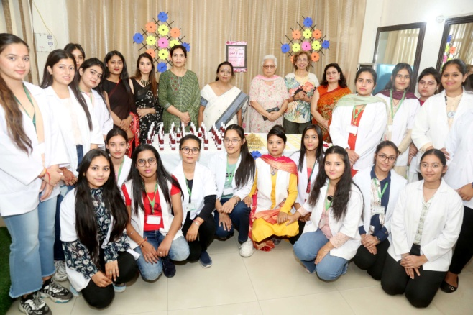

PG Department of Cosmetology of Hans Raj Mahila Maha Vidyalaya, Jalandhar organized Entrepreneurial Workshop-cum-Sale under the aegis of startup KAAYA under the able guidance of Principal Prof. Dr. (Mrs.) Ajay Sareen. In this workshop students of Cosmetology made organic rose water (from original rose petals) which can use as rejuvenating facial toner. The students also made cleanser cum scrub for cleaning and exfoliation. Mrs. Navroop, Incharge , Ms. Mukti , Head PG Department of Cosmetology welcomed Principal Dr. Ajay Sareen and guests. Students have analyzed the skin with skin analyser and guide the clients about how to do skin treatments at home from kitchen ingredients for different types of skin and also cleared various doubts of clients. Principal Dr. Ajay Sareen appreciated a lot for this effort of department and congratulated the department. She said that the aim of this workshop is to make the students self sufficient and motivate them towards entrepreneurship. Ms. Aditi and Ms. Manpreet from Cosmetology Department were also present.

Wednesday, 27 April 2022

Tech Skill Enhancement and Trouble Shooting Workshop organized at HMV
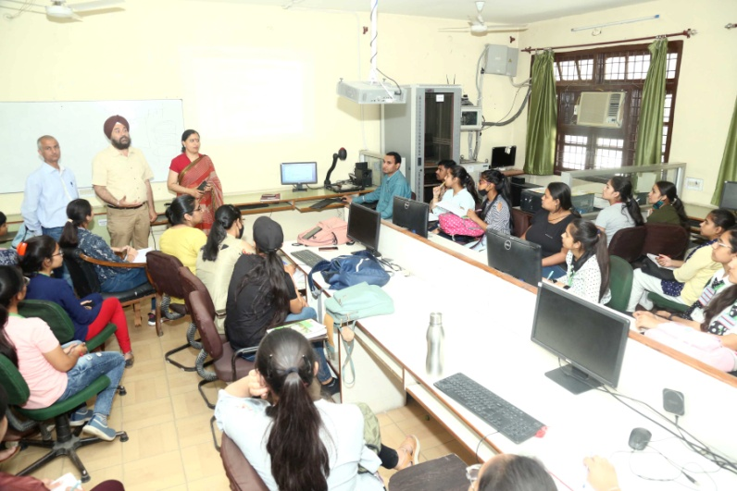

The PG Department of Computer Science and IT of Hans Raj Mahila Maha Vidyalaya, Jalandhar organized 3 day workshop on “Tech Skill Enhancement and Trouble Shooting.” More than 50 students participated in the workshop. The students were told about Hard Disk Partitioning, Installation of Windows, Operating System, Hardware Trouble Shooting, Printer Installation and Sharing, Office Automation, Software Installation and Installation of Utility Software through internet. Students were also made aware about the risks while downloading software through internet. Students learned all this by doing practical in labs. They showed keen interest in hands on session. Mr. Gullagong, Mr. Gurmeet Singh, Mr. Ravinder Mohan Jindal, Mr. Jagjit Bhatia, Mrs. Urvashi and Mr. Pardeep Mehta were the Resource Persons. Mr. Rajesh Kumar provided all the technical assistance for the workshop. Mr. Anil Bhasing, Incharge Computer Club framed the layout of the workshop under the guidance of Principal Prof. Dr. (Mrs.) Ajay Sareen and Head of Department Dr. Sangeeta Arora. Principal Dr. Ajay Sareen appreciated the efforts of the department and said that the prime focus of the institution is to make the students self sufficient and independent which was achieved by the workshop.

Friday, 29 April 2022

Dancing Toes Workshop Concluded at HMV
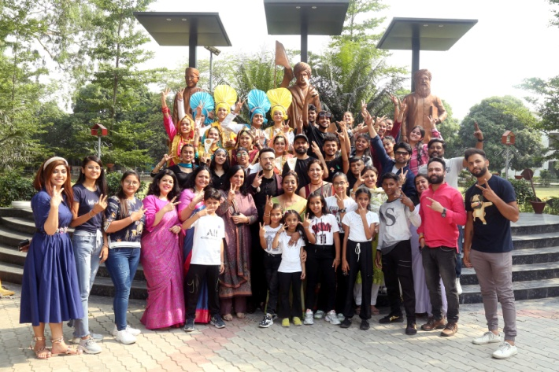
Hans Raj Mahila Maha Vidyalaya, Jalandhar organized a three-day workshop “Dancing Toes” in collaboration with 91.9 FM Radio City under the inspiring guidance of Principal Prof. Dr. (Mrs.) Ajay Sareen. Mr. Aftab Rajat and team from Firing shoes demonstrated different forms of Bhangra, Zoomba and Aerobics to the energetic participants. Ms. Twinkle and Ms. Harpreet from Tap and Toes also taught dance techniques through their vibrant performances. The workshop concluded on the occasion of World Dance Day. Principal Dr. Ajay Sareen extended a green welcome to the guests to the occasion. Dr. Sushma Chawla, Member Local Committee, Mr. Gagun Bedi renowned Choreographer. Mrs. Seema Soni, Director Punjab & Haryana Radio City, Dr. Partap Pati, Head Biotech GNDU, Dr. Sandeep, Head Computer Science, GNDU and Mrs. Shweta. Principal Dr. Ajay Sareen congratulated Dr. Pooja Manhas, Mrs. Navroop and Mrs. Veena Arora for the successful conduct of workshop. She felt elated to share that Dance Department of HMV has been elevated to Post Graduation Department. She remarked that dance is a great stress buster and thus refreshes us to live our lives with energy and exuberance. The stage rocked with the youthful performances of students and children, soulful performance of Dr. Sushma Chawla, Bhangra, Classical Dance and Dances by Firing Shoes. The event was successfully coordinated by Mrs. Navroop, Mrs. Veena Arora, Dr. Pooja Manhas, Mrs. Savita Mahendru and Mrs. Shefali. The stage was hosted by Dr. Anjana Bhatia, R.J. Karan, RJ Sandy and RJ Himanshu from Radio City. The audience danced to the tunes of the performances and workshop came to a spectacular close with a group salsa dance by Choreographer Gagun Bedi.

Monday, 16 May 2022

HMV Organized a Seminar on Healthcare and Cancer Awareness

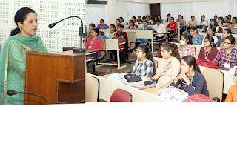
Department of Zoology, Hans Raj Mahila Maha Vidyalaya, Jalandhar organized a seminar on Healthcare and Cancer awareness under the able guidance of Principal Prof. Dr. (Mrs.) Ajay Sareen. Dr. Seema Marwaha, Dean Academics and Head of Zoology Department accorded a warm welcome and green greeting to Dr. Sandali Ghai Bhutani, Gynaecologist at Ghai Hospital, Jalandhar. Dr. Sandali delivered a talk to create awareness about Women Health and Hygiene. She discussed about menstrual problems, PCOD and cervical cancer in women. She emphasized on daily exercise, change in lifestyle and health diet as a preventive measure against the above diseases. She also gave menstrual health tips to the students and advised them to maintain hygiene and healthy body weight. She responded to the queries raised by the students to their satisfaction. Ms. Jaspreet Kaur and Ms. Baljeet Kaur also accompanied Dr. Ghai. They talked about the proper use of cotton based sanitary napkins. Principal Dr. Ajay Sareen appreciated the efforts of Zoology Department to spread awareness regarding importance of Women Health and Hygiene. She further added that the institution is already taking care of women’s health as incinerators for proper disposal of used sanitary napkins are installed in ladies’ washrooms. Dr. Seema Marwaha gave the vote of thanks and that women health is utmost important for a healthy family. The stage was conducted by Dr. Sakshi Verma and the event was well organized by Mr. Ravi Kumar. Lab attendant Mr. Sachin and Technicial staff member, Mr. Rajesh assisted in making all arrangements.

Friday, 20 May 2022

One Day Workshop on Facial Electropathy in HMV
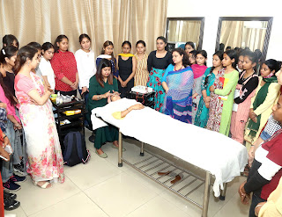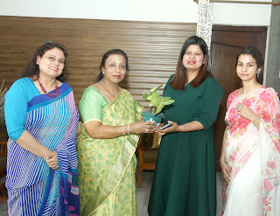
PG Department of Cosmetology of Hans Raj Mahila Maha Vidyalaya, Jalandhar organized one day workshop on Facial Electropathy. The Resource Person was Mrs. Gargi, Skin Expert from Cheryl. Principal Prof. Dr. (Mrs.) Ajay Sareen welcomed her. Mrs. Gargi told the students about basic purpose and benefits of facial along with basic skin care regime. She also gave demonstration on facial treatment with various electric gadgets. Principal Dr. Sareen appreciated the workshop and motivated the faculty to provide such practical knowledge to students in future also. On this occasion, Head, PG Department of Cosmetology Ms. Mukti Arora, Ms. Aditi and Ms. Manpreet were also present.

Saturday, 28 May 2022

A workshop on Translation conducted at HMV
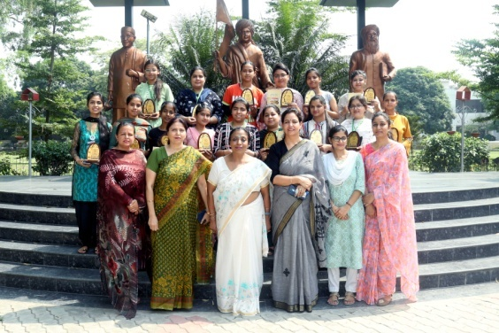
Post Graduate Punjabi Department of Hans Raj Mahila Maha Vidyalaya, Jalandhar conducted a 10 day short term course cum workshop on Translation under the support and guidance of Principal Prof. Dr. Ajay Sareen and Mrs. Navroop, Head of Punjabi Department. The resource persons included experts from various colleges as well the faculty members of HMV. The list included the names of Advocate Madhu Rachna, Deputy Editor of Punjabi Jagran, Mr. Arundeep, Writer and Poet Harkhi Virk from Australia who shared their views on Translation and its Rules, Translation and Media, Translation and Diasporic Literature respectively. Faculty members, Dr. Jyoti Gogia, Head Hindi Department, Mrs. Kuljit Kaur, Punjabi Department, Dr. Meenu Talwar, Head Sanskrit Department, Mrs. Protima Mander, Head History Department, Dr. Mandeep Kaur, Dr. Sandeep Kaur and Ms. Manpreet Kaur shared their views on the concepts, types, importance, history,linguistic perspective, folklore perspective, etc. of translation. Principal Prof. Dr. (Mrs.) Ajay Sareen distributed certificates to all the participants in the valedictory function and explained the importance of the art of translation. She encouraged the students to move forward and said that such workshops help in the development of the students’ Skills. Mrs. Kuljit Kaur In charge of this workshop congratulated the students on completion of this course and wished them all the best for the future. Head of Punjabi Department, Mrs. Navroop highlighted the importance of translation in the face of globalization challenges and encouraged the students to apply the lessons learned from this workshop in their future lives. On this occasion Co-Incharge Dr. Sandeep Kaur and Dr. Mandeep Kaur also congratulated the students, Mrs. Veena Arora and Ms. Pawandeep from Punjabi Department were also present on the occasion.

Sunday, 12 June 2022

Department of Biotechnology of HMV Conducted One Day Seminar
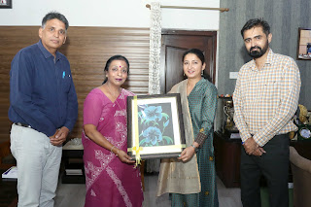
A one day DBT sponsored seminar was organized by the Department of Biotechnology on the topic “Biotechnology in Investigating Gut-Brain Axis” under the able guidance of worthy Principal Prof. Dr. (Mrs.) Ajay Sareen. The Resource Person for the day was Dr. Gazal Sharma, Assistant Professor, Department of Food Science and Technology, IKG Punjab Technical University, Kapurthala. She explained in her lecture that micro flora of stomach effects the functioning of brain. She further added the significance of diet components on the growth and development of bacteria in stomach. She stressed the need to consume probiotics such as yoghurt, curd etc. and discuss the various brain diseases such as headache, migrainpain etc. can be prevented by the use of different natural health supplements. In the end Dr. Jitender Kumar, Head of Biotechnology Department has given vote of thanks to the worthy guest and others who had helped in organizing the seminar. Principal Dr. Ajay Sareen congratulated the department and honoured the Resource Person. Faculty members Dr. Anjana Bhatia, Dr. Harpreet Singh, Ms. Purnima Sharma, Dr. Nitika Arora, Ms. Ramandeep Kaur, Ms. Harpreet Kaur and Mr. Sumit Sharma were also present on the occasion.

Thursday, 2 June 2022

A Seminar on Good Health….A path to happiness

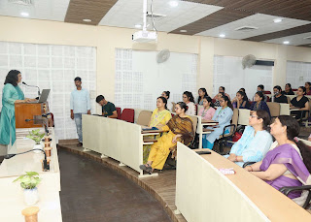
Youth Red Cross Society and R. Venkatraman Chemical Society of Hans Raj Mahila Maha Vidyalaya, Jalandhar organized a seminar on the topic “Good Health….A path to happiness” under the able guidance of Principal Prof. Dr. (Mrs.) Ajay Sareen. Dr. Seema Pasricha, Gynaecologist, Pasricha Hospital, Jalandhar was the Resource Person. Dr. Neelam Sharma, Head, Chemistry Department and Mrs. Deepshikha, Incharge, Red Cross Society welcomed Dr. Pasricha with green greetings. Dr. Pasricha discussed the importance of good health, various factors affecting the physical health as well as mental and social health and common health problems especially faced by women like anaemia and obesity. She also talked about menstrual hygiene and increasing problem of PCOS among young girls. She also explained mantras of good health like yoga, meditation, balanced diet. 60 students of science department participated in the seminar and listened to the talk enthusiastically, shedding inhibitions interacted with Dr. Pasricha raising lots of queries, which were explained in details by her. Principal Prof. Dr. (Mrs.) Ajay Sareen congratulated the department and society for organizing such fruitful seminar. She said that health of females is of prime importance. They should be made aware about it. On this occasion, Mrs. Saloni Sharma, Dr. Vandna Thakur and Ms. Tanisha were also present.

Monday, 13 June 2022

HMV Organized Skilled Course Certificate Programme in Personality Development and Soft Skills Training – Beginner’s Level

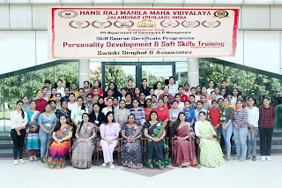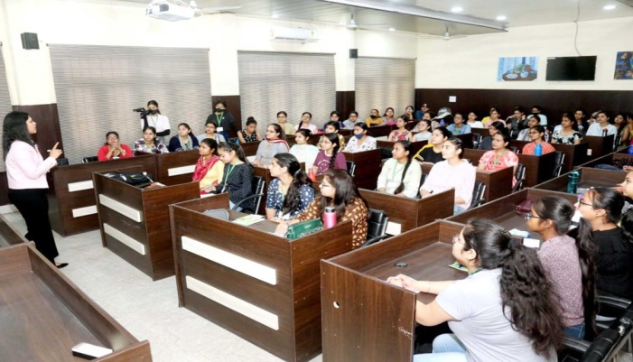
Commerce Club of P.G. Department of Commerce and Management of Hans Raj Mahila Maha Vidyalaya, Jalandhar organised a skilled course certificate programme in Personality Development and Soft Skills Training in collaboration with Swinki Singhal and Associates, under the able guidance of Principal Prof. Dr. (Mrs.) Ajay Sareen. As per the tradition of HMV, Programme started with Gaytri Mantra to seek blessings of Almighty. The session began with formal welcome and green greetings by Coordinator Ms. Binoo Gupta, Dean Student Welfare, Ms. Shefali Kashyap and Ms. Kanika Sharma, Incharges Skill Programme. Ms. Binoo Gupta, Coordinator of the programme briefed that such programmes aimed at enabling students to explore their hidden potential and helps in grooming their personality. Total 72 students from B.Com and B.B.A participated in the program. Various training sessions were conducted by CA Swinki Singhal. Students were guided on Time Management, Stress Management, Goal Setting and Public Speaking. Practical knowledge was imparted through Mock Telephonic Conversation, Role Plays, Group Discussion. They were also told about Wardrobe Management, Corporate Readiness, Handling and Surviving in Corporate Environment. Students were involved through various fun activities and video clips to provide experiential learning. Students Km. Mehak, Km. Deepali , Km. Apporva and Km. Diksha were honoured by CA Swinki Singhal for their active participation. On the valedictory day Principal Prof. Dr. (Mrs.) Ajay Sareen congratulated the participants and the Organizing Committee and told that the prime focus of our institution is to make the students self-sufficient & independent and it was achieved through such programmes. Mrs. Meenu Kohli, Head PG Department of Commerce and Management encouraged students to join such programmes for their personal grooming and to enhance self confidence. Vote of thanks on the concluding day was given by Ms. Shefali Kashyap and Ms. Kanika Sharma, course incharges. Stage was conducted by Ms. Anmol and Ms. Shayna Monga. Technical assistance was provided by Mr. Vidhu Vohra. Dr. Seema Khanna, Ms. Kajal Puri, Ms. Shilpa Goyal and Ms. Sonal graced the occasion with their presence.

Wednesday, 15 June 2022

HMV Organized One Day Workshop on Tips and Tricks for Different Cultural Items

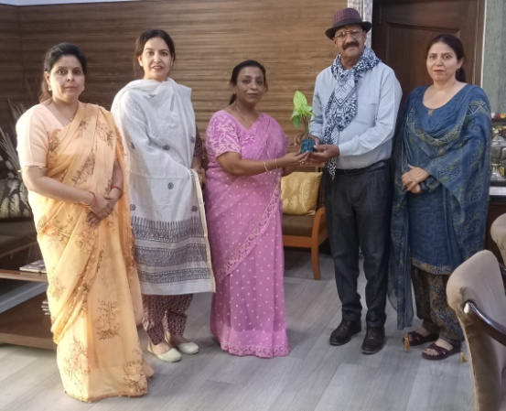
Under the able guidance and encouraging support of Principal Prof. Dr. (Mrs.) Ajay Sareen, Youth Welfare Department and PG Hindi Department of Hans Raj Mahila Maha Vidyalaya, Jalandhar organized One Day Workshop on the topic, “Tips and Tricks for Different Cultural Items.” Eminent Speaker and Writer Dr. M. Rafi was invited as a Resource Person for the event. Principal Prof. Dr. (Mrs.) Ajay Sareen welcomed the speaker by giving a planter and gift. Dr. Jyoti Gogia, Head, PG Department of Hindi started the workshop by giving a brief introduction of Dr. Rafi. Mrs. Navroop, Dean Youth Welfare Department gave a formal welcome to the speaker. Dr. Rafi began his talk by showing a few incidents from his difficult childhood and inspired the students to never give up in life. He further added that no matter how terrible the circumstances might be in someone’s life but with education and determination anything can be achieved. Then he shared various techniques of drama, poetry and debate and invited some students from the audience to give them a firsthand experience of his tips and tricks for different cultural items. Dr. Prem Sagar, Head Department of Music Vocal dedicated a song in praise of Dr. Rafi which was relished by all. Principal Prof. Dr. (Mrs.) Ajay Sareen appreciated the efforts of Youth Welfare Department and Hindi Department for their efforts. She said that art is an important part of our life. She said that such workshops make our student feel more confident and holistically developed. Mrs. Navroop concluded the workshop by giving vote of thanks. On this occasion Dr. Ashmeen Kaur, Coordinator , IQAC, Mrs. Mamta, Mrs. Kuljeet Kaur, Mrs.Veena Arora and Mrs. Nita Malik were also present.

Saturday, 18 June 2022

HMV Organized a camp on Financial Literacy and Investment Planning
Hans Raj Mahila Maha Vidyalaya, Jalandhar organized three day Block Level Camp on Financial Literary and Investment Planning in collaboration with Nehru Yuva Kendra. The Chief Guest of the camp was Principal Prof. Dr. (Mrs.) Ajay Sareen. The programme started with lighting of the lamp. Principal Dr. Ajay Sareen addressed the gathering and said that such programmes are very useful. She said that small investments proves to be big gains in future. We should always invest carefully because right investment can give us right benefits. District Guidance Counsellor Mr. Surjit Lal gave a brief introduction of the programme. Coordinator of the Programme Dr. Anjana Bhatia (Dean Innovation and Research) addressed the students and said that we should invest carefully because what we invest today, will bring us benefits for sure. We make our life secure by investing. On this occasion, Mr. Rishav Singla from Nehru Yuva Kendra also addressed the gathering. He told in detail about various investment schemes in Bank, Post Office, Share Market, Mutual Funds etc. Dr. Shallu Batra from HMV discussed about pros and cons of various investment plans. Mr. Darshan Pandey from Cyber Cell, Jalandhar told about various crimes done on internet by forge investment companies. Inspector Sanjeev said that we should be very careful while investing our hard earned money. As Resource Person Dr. Minakshi Duggal Mehta from HMV was also present. On this occasion, Sh. Kulwinder Kumar, Sh. Vishal Singh, Ms. Kajal, Dr. Meenu Talwar and Ms. Sukriti were also present.

Tuesday, 21 June 2022

HMV celebrated International Yoga Day
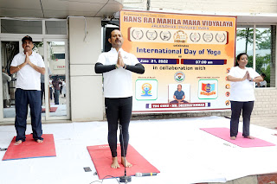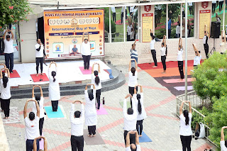

Spreading awareness about the benefits of Yoga and participating in the mass campaign initiated by Government of India, Hans Raj Mahila Maha Vidyalaya, Jalandhar celebrated International Yoga Day in collaboration with Ministry of Aayush and 2 Pb. Girls Battalion, NCC under the inspiring support of Principal Prof. Dr. (Mrs.) Ajay Sareen. Brig. I.S. Bhalla, Group Commander and CO 2 Pb. Battalion NCC Col. NPS Toor formed a part of the celebration along with 350 cadets, Ex-cadets, NSS Volunteers, students from Sports Department and faculty and staff of HMV. Yoga Guru Mr. Dheeraj Kumar made the participants perform various asans. Everyone enjoyed the cool breeze of the morning and performed the yoga with enthusiasm. Principal Dr. Ajay Sareen extended green welcome to the guests and emphasized on the benefits of doing yoga daily. She said that this ancient practice rejuvenates the physical as well as mental state and provides strength and resilience. The event was expertly conducted by Dr. Anjana Bhatia.

Monday, 20 June 2022

HMV organised National E-Seminar on Sustainable Uses of Biodiversity
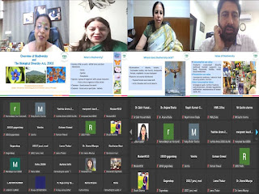

A one day National e-seminar on “Sustainable Use of Biodiversity Entrepreneurship Opportunities” was organized by Hans Raj Mahila Maha Vidyalaya, Jalandhar in collaboration with Punjab Biodiversity Board. Principal Prof. Dr. (Mrs.) Ajay Sareen welcomed the guests and dignitaries and said that HMV and Punjab Biodiversity Board are committed to conservation of Biodiversity and spreading awareness for the same. The chief-guest of the seminar was Dr. Jatinder Kaur Arora, Executive Director, Punjab State Council for Science & Technology and Member Secretary, Punjab Biodiversity Board. She emphasized the importance of Biodiversity management and shared that Punjab is among few states wherein, Biodiversity Management Committees have been constituted. Dr. Gurharminder Singh, Principal Scientific Officer, Punjab State Council for Science and Technology explained about the sustainable use of Biodiversity and Biodiversity Act. Dr. Anjana Bhatia, Head of the Department of Botany talked on the use of various plants. Participants from places like Bihas, Jammu, Kashmir, Uttar Pradesh, Sikkim etc. participated in the seminar. Dr. Nitika, Mrs. Ramandeep Kaur, Ms. Harpreet Kaur and Dr. Shuchi were also present on this occasion along with the students of Botany Department. International Biodiversity Day-2022 was also organized on this occasion at HMv. Students of HMV Collegiate Senior Secondary School participated in Selfie with Nature competition, Kumud, Gurjot and Mehak were declared winners. Simarjit Kaur, Bhumi and Manmeet were given first, second and third prizes respectively, in the paragraph writing competition. Kiranjot, Shafri Neerja were awarded in photography competition. Komal, Bhumika and Diya were awarded in Promote Eco Park Competition. Alina got Best poster award, Neha, Manreet, Simranjit, Gurleen, Jhanvi and Simran emerged victorious in the quiz. Dr. Anjana Bhatia thanked Principal Dr. Ajay Sareen and School Coordinator Mrs. Meenakshi Syal for their continued support.

Thursday, 23 June 2022

HMV Organized Annual Art Exhibition
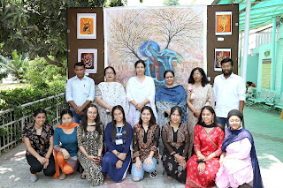
Under the aegis of Punjab Government’s DBT Star Scheme for Colleges and seeking the able guidance of Principal Prof. Dr. (Mrs.) Ajay Sareen, a seven day Faculty Development Programme (FDP) on ‘Guru Siddhta’ was started on 24th June, 2022 in the premises of Hans Raj Mahila Maha Vidyalaya, Jalandhar. The event was commenced by following the ceremony of holy lamp and DAV gaan. Justice (Retd.) Sh. N.K. Sood – Vice President of DAV College Managing Committee and Chairman Local Committee and Dr. Satish Ahuja – Principal Director of DAV Institute of Management, Faridabad made their presence as the chief guests of the occasion. In the first session of FDP, Dr. Aneesh Dua – Dean students’ Welfare, Zoology Department, Guru Nanak Dev University Amritsar and in the second session, Dr. Maisha Sikka – Dietician, Tagore Hospital, Jalandhar were the Chief Guests. Principal Prof. (Dr.) Mrs. Ajay Sareen welcomed the Chief Guests by presenting them planters. Further, Dr. Ajay Sareen stressed upon the importance of Faculty Development programme and said that knowledge seeks no age. She said, a student’s life is really indispensible in which they learns many techniques and methods in order to make their life complete. A real teacher can be one who teaches his students by using convincing tools and pedagogy. In addition to this, Dr. Satish Ahuja focused upon the essentials of Faculty Development Programme and said that such sorts of learning programmes enhance the personality of a teacher. Justice (Retd.) Sh. N.K. Sood also presented his views and remarked that a teacher is the reason of producing doctors, engineers and officers. Therefore, a Teacher is the highly-esteemed personality in our society. In the first session of FDP, Dr. Aneesh Dua discussed about the contemporary requirements in the teaching-learning process. Moreover, he said, a teacher must be a role model for his students. We should not present teaching profession as a burden. We should also indulge ourselves in learning something new so that our education system could be strengthened. In the second session of FDP, Dr. Manisha Sikka presented her views on balanced diet. She said, if we follow a balanced and healthy diet in our day to day life then we can render our services in a correct manner. A healthy life helps in the completion of every work. Dr. Anjana Bhatia was the coordinator for the occasion. Progamme Convener Mrs. Saloni, Organizer Dr. Harpreet Singh, Incharge of Core Committee Dr. Seema Marwaha, Dr. Neelam Sharma, Dr. Anil Bhasin, Dr. Jatinder Kumar, Mrs. Gagandeep, Dr. Rakhi Mehta, Mr. Ashish Chadha were also present. Mrs. Saloni Sharma, Head Physics Department presented vote of thanks.

